Hereford and Borders Winter Cross Country League 2023/24
Race 2 – Croft Castle. Sunday November 12 2023
Hosted by Croft Ambrey Running Club.
11am start.
Venue
By kind permission of the National Trust
Croft Castle, Yarpole ,Leominster
HR6 9PW
Off the B4362 between Mortimer’s Cross and Bircher Village.
There is a one-way system to enter and leave Croft Castle. People attending for the junior races before 10am will be directed to enter via the exit drive. After 10am please follow the one way system, following the signs on the B4362 to the car park at Croft Castle.
Parking
This will be at the Croft Castle National Trust visitor carpark.
Car parking space is limited – The Castle and Grounds will be open to visitors to the National Trust and parking for paying visitors is priority.
Please make every effort to car share.
As requested by the National Trust, we will be collecting £3 from all cars with runners as a donation to the National trust at Croft Castle in recognition for allowing us to host the race. As this is not a National Trust event, this will apply to all cars with runners, irrespective of National Trust membership.
This will be collected on entry to the carpark. Please have the correct change ready when asked.
Parking is close to the race start – there is no dry storage for kit, please keep all items it in your car.

Facilities
Please use the National Trusts Toilets sited next to the tearooms.
Please be considerate to paying NT visitors and allow them to the front if there are any queues.
Please remove muddy trainers before entering the toilets, tea room or any other indoor NT facility.
Cold refreshements will be served at the end of the race free to all runners.
Hot refreshments are available to all to purchase from the NT tearooms.
First aid will be provided by 365 medical solutions. 07761859643.

Senior course – one lap approximately 9km.
The course will take place on National Trust land – on gravel tracks and grassland. Depending on the weather, it is likely to be muddy or rutted in sections and trail shoes are advised.
Please be aware that the route follows footpaths which are likely to be in use by walkers and visitors to Croft Castle Parkland.
It will be marked and well marshalled. (marshal points in red, signage in green
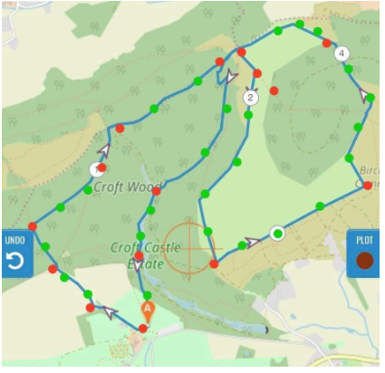
Junior Course
Juniors over 17 will start with the senior race at 11am and be guided by marshals to take a shorter route across Bircher Common.
This will be 6.1km.
Please ensure all junior runners their race number outlined in blue to make them easily identifiable to the marshals.
Team captains should take the time to talk to junior runners to ensure they are aware that they will be directed to a different route after three miles and should follow the marshals’ instructions.
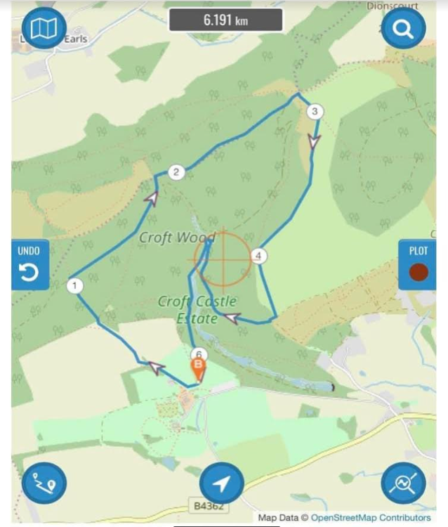

The U11/U13/U15 course is a lapped course of map below which is a 1km loop
U11 - 9.30am
U13 & U15 10am (race bib outlined in red for U13)
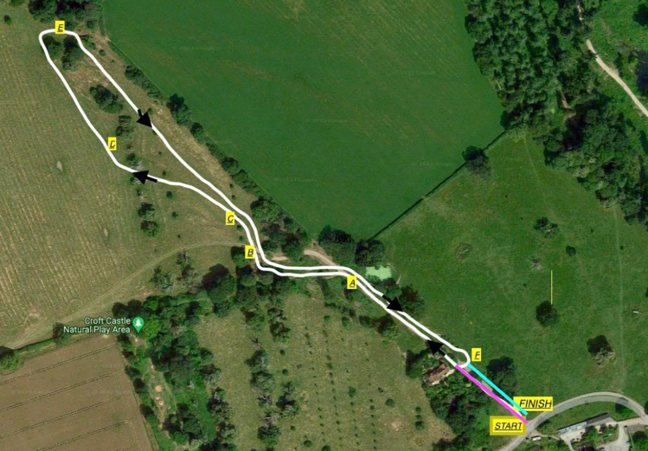
U11 - 2 laps
U13 - 3 laps
U15 - 4 laps

Event director: Huw Williams. huw@croftambreyrunningclub.co.uk
Race Official: Ashley Burridge.
Race licence no.2023/0997

